

# Rossmoyne Senior High School

### Semester Two Examination, 2016

### Question/Answer Booklet

# MATHEMATICS

**SPECIALIST**

**UNITS 3 AND 4**

## Section One:

## Calculator-free

**Your name**

**Teacher**

## Time allowed for this section

Reading time before commencing work: five minutes

Working time for section: fifty minutes

## Materials required/recommended for this section

***To be provided by the supervisor***

This Question/Answer Booklet

Formula Sheet

***To be provided by the candidate***

Standard items: pens (blue/black preferred), pencils (including coloured), sharpener, correction fluid/tape, eraser, ruler, highlighters

Special items: nil

## Important note to candidates

No other items may be taken into the examination room. It is **your** responsibility to ensure that you do not have any unauthorised notes or other items of a non-personal nature in the examination room. If you have any unauthorised material with you, hand it to the supervisor **before** reading any further.

## Structure of this paper

|  |  |  |  |  |  |
| --- | --- | --- | --- | --- | --- |
| Section | Number of questions available | Number of questions to be answered | Working  time (minutes) | Marks available | Percentage of exam |
| Section One:  Calculator-free | 8 | 8 | 50 | 52 | 35 |
| Section Two:  Calculator-assumed | 12 | 12 | 100 | 97 | 65 |
|  | | | **Total** | 149 | 100 |

## Instructions to candidates

1. The rules for the conduct of examinations are detailed in the school handbook. Sitting this examination implies that you agree to abide by these rules.

2. Write your answers in this Question/Answer Booklet.

3. You must be careful to confine your response to the specific question asked and to follow any instructions that are specified to a particular question.

4. Spare pages are included at the end of this booklet. They can be used for planning your responses and/or as additional space if required to continue an answer.

* Planning: If you use the spare pages for planning, indicate this clearly at the top of the page.
* Continuing an answer: If you need to use the space to continue an answer, indicate in the original answer space where the answer is continued, i.e. give the page number. Fill in the number of the question that you are continuing to answer at the top of the page.

5. **Show** **all your working clearly**. Your working should be in sufficient detail to allow your answers to be checked readily and for marks to be awarded for reasoning. Incorrect answers given without supporting reasoning cannot be allocated any marks. For any question or part question worth more than two marks, valid working or justification is required to receive full marks. If you repeat any question, ensure that you cancel the answer you do not wish to have marked.

6. It is recommended that you **do not use pencil**, except in diagrams.

7. The Formula Sheet is **not** to be handed in with your Question/Booklet.

Section One: Calculator-free 35% (52 Marks)

This section has**eight (****8)** questions. Answer **all** questions. Write your answers in the spaces provided.

Working time for this section is 50 minutes.

Question 1 (5 marks)

The polynomial $h\left(z\right)=z^{4}-6z^{3}+3az^{2}-30z+10a$, where $a$ is a real constant, has a zero of $3-i$. Determine the value of $a$ and all other zeros of $h(z)$.

Question 2 (8 marks)

Two functions are defined by $f\left(x\right)=\sqrt{3x-1}$ and $g\left(x\right)=\frac{1}{x}$.

(a) Determine the composite function $f(g\left(x\right))$ and the domain over which it is defined.

(3 marks)

(b) Sketch the graph of $y=g(g\left(x\right))$ on the axes below. (2 marks)

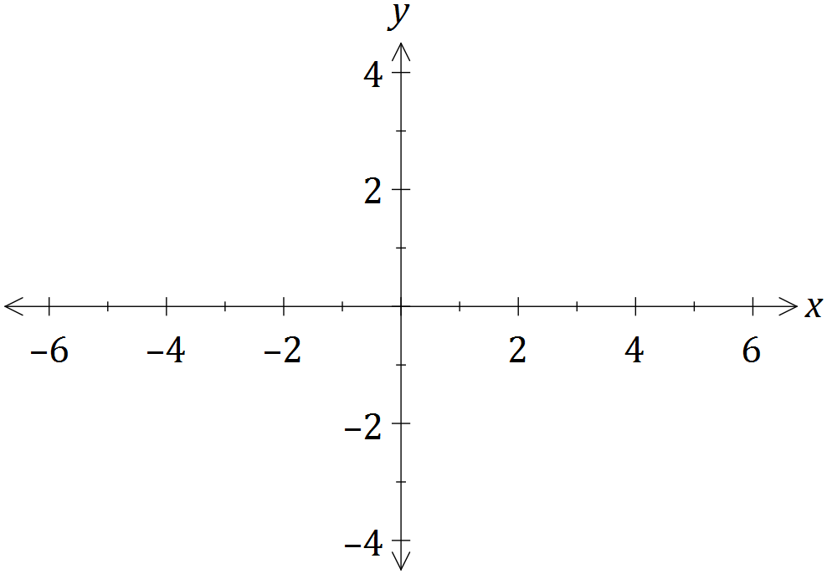

(c) The graph of $y=f(x)$ is shown below, passing through point $P$ with coordinates $(2.62, 2.62)$. Determine $f^{-1}(x)$, the inverse of $f(x)$, and sketch the graph of $y=f^{-1}(x)$ on the same axes. (3 marks)

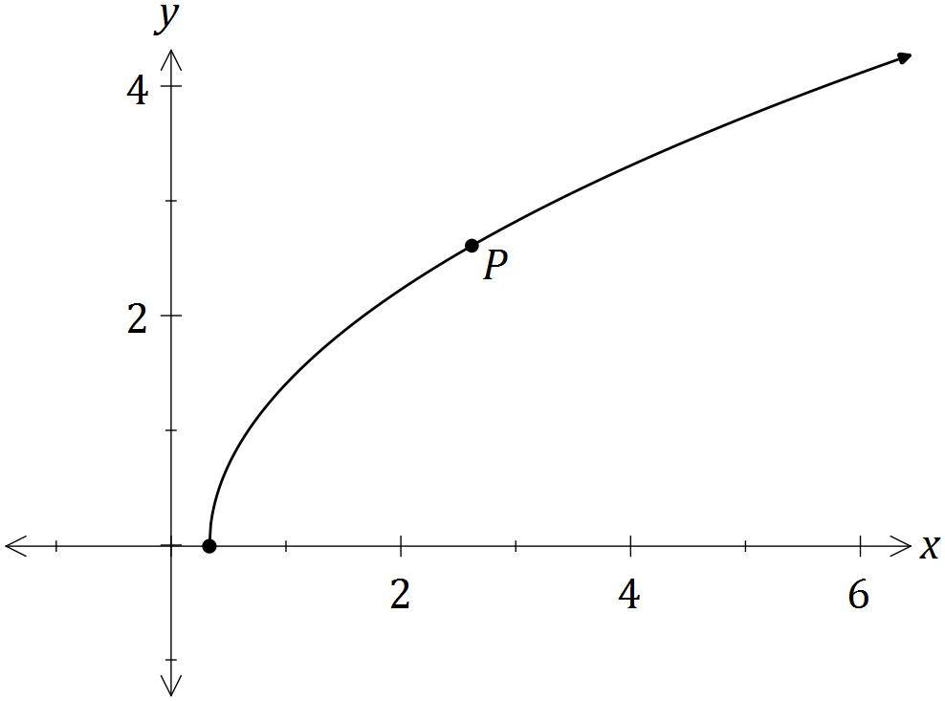

Question 3 (5 marks)

An object, initially at rest, is dropped from the top of tall building so that after $t$ seconds it has velocity $v$ meters per second.

The air resistance encountered by the object is proportional to its velocity, so that the velocity satisfies the equation $\frac{dv}{dt}=10-kv$, where $k$ is a constant.

(a) Express the velocity of the object in terms of t and k. (4 marks)

(b) Sensors on the object indicate that its velocity will never exceed 55 metres per second. Determine the value of the constant k. (1 mark)

Question 4 (5 marks)

Let $v=\frac{\sqrt{2}}{2}-\frac{\sqrt{2}}{2}i$.

(a) Express $v$ in polar form. (2 marks)

(b) Show that $v^{4}=-1$. (1 mark)

(c) Plot the roots of $z^{4}+1=0$ on the following Argand diagram. (2 marks)

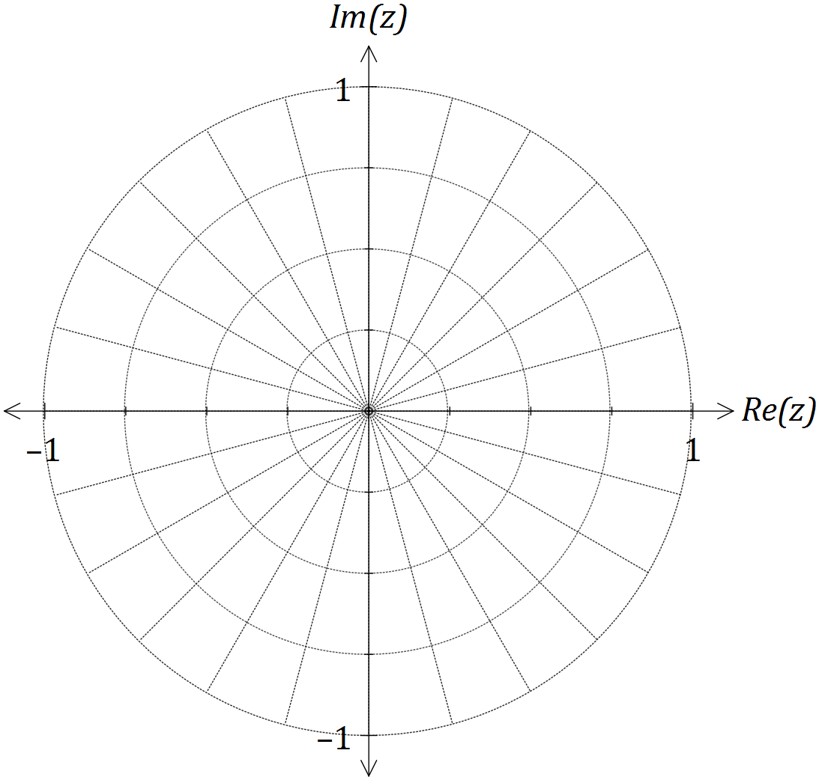

Question 5 (8 marks)

(a) Using partial fractions, or otherwise, determine $\int{\frac{x-19}{(x+1)(x-4)}}dx$. (4 marks)

(b) Use the substitution $u=\sin{x}$ to evaluate $\int_{\frac{π}{6}}^{\frac{π}{2}}{\frac{cos⁡x}{\sqrt{\sin{x}}}}dx$. (4 marks)

Question 6 (5 marks)

The differential equation $y^{'}=\frac{2x}{y}$ is shown in just one of the four slope fields below.

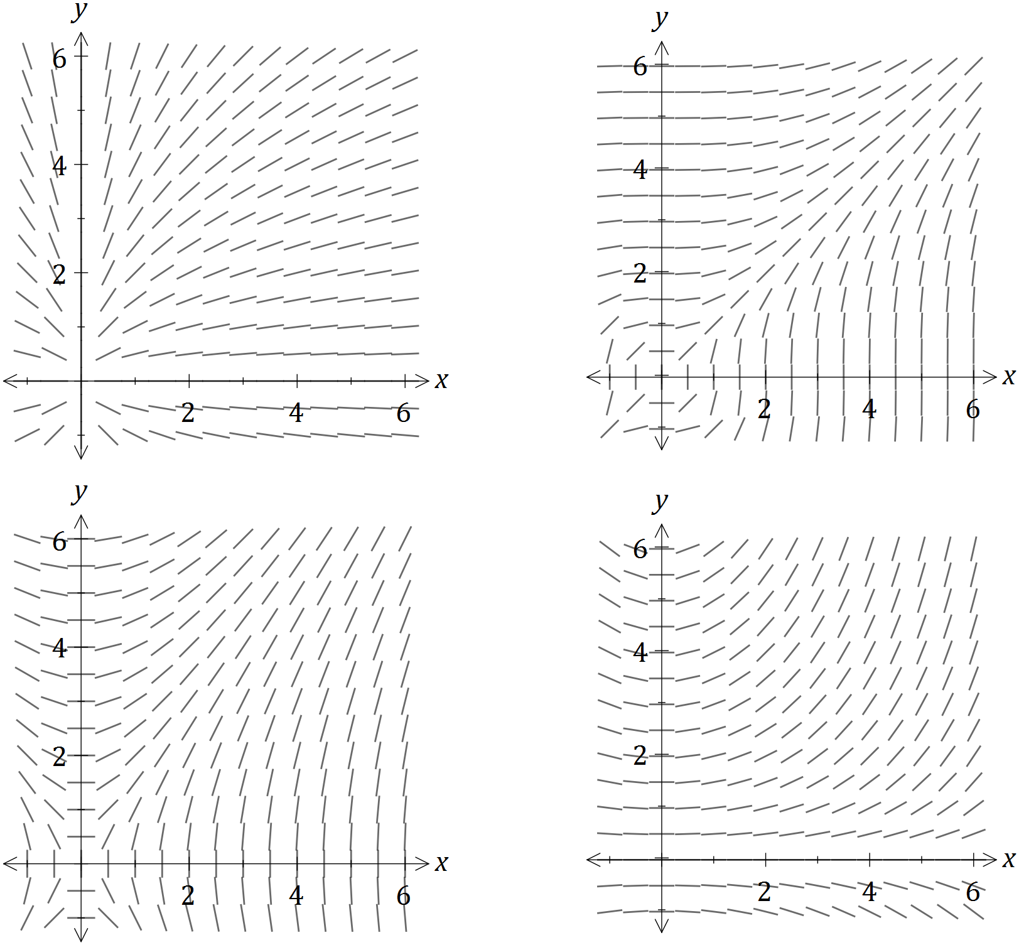

(a) On the slope field for $y^{'}=\frac{2x}{y}$, sketch the solution of the differential equation that passes through the point $(2, 4)$. (3 marks)

(b) Another solution to the differential equation passes through the point $\left(6, -3\right).$ Use the incremental formula $δy≈\frac{dy}{dx}×δx$, with $δx=\frac{1}{10}$, to estimate the y-coordinate of this curve when $x=6.1$. (2 marks)

Question 7 (8 marks)

The function $f$ is defined as $f\left(x\right)=\frac{x^{2}-1}{x^{2}+1}$.

(a) Show that the **only** stationary point of the function occurs when $x=0$. (2 marks)

(b) Sketch the graph of $y=f(x)$ on the axes below. (3 marks)

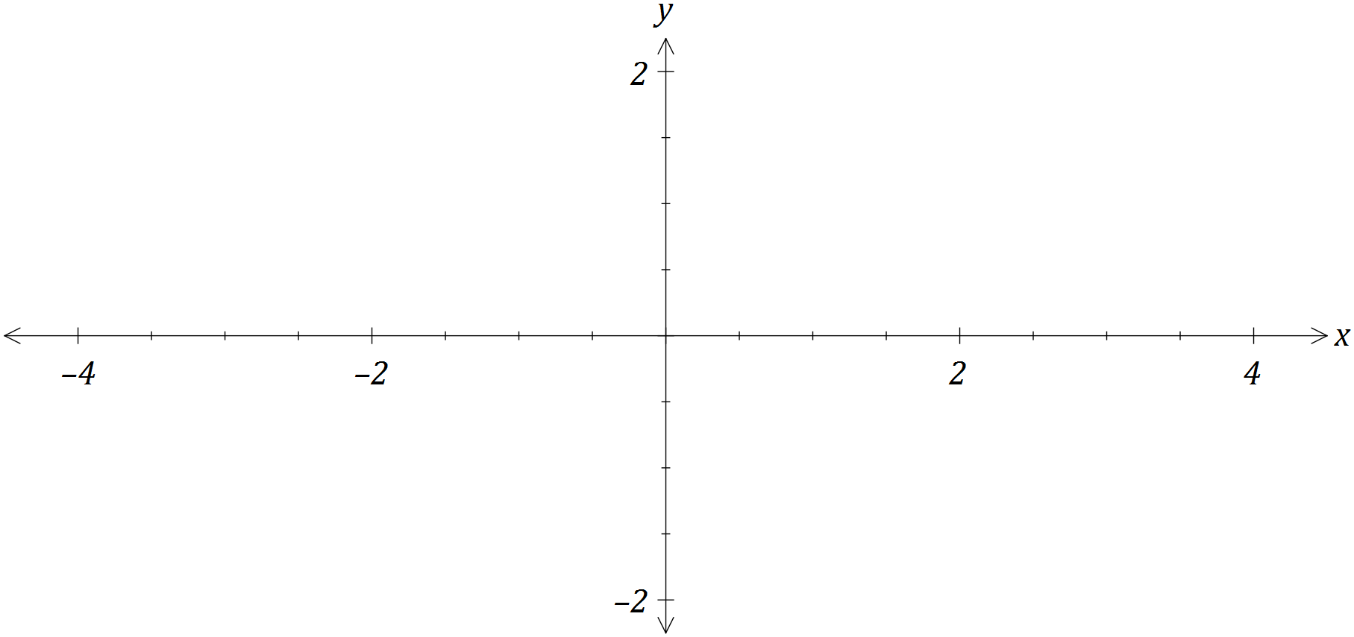

(c) Using your graph, or otherwise, determine all solutions to

(i) $f\left(x\right)=\left|f(x)\right|$. (1 mark)

(ii) $f\left(x\right)=f(\left|x\right|)$. (1 mark)

(iii) $f\left(x\right)=\frac{1}{f\left(x\right)}$. (1 mark)

Question 8 (8 marks)

A region is bounded by $x=0, y=0$ and $y=\ln{(x+3)}$ as shown in the graph below.

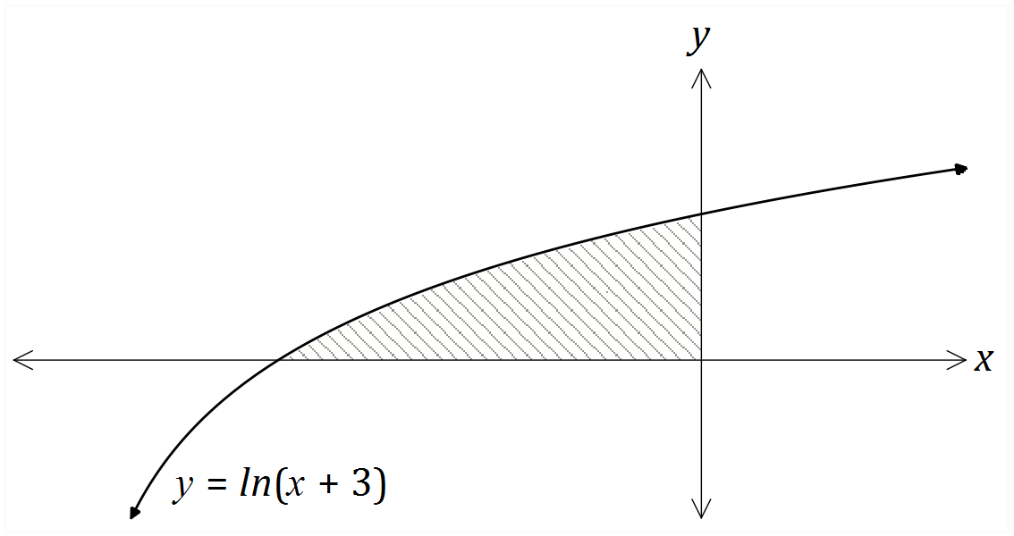

(a) Show that the area of the region is given by $\int_{0}^{\ln{3}}{({3-e}^{y})}dy$. (3 marks)

*(Do not evaluate the integral).*

(b) Determine the volume of the solid generated when the region is rotated through $2π$ about the y-axis. (5 marks)

Additional working space

Question number: _________

© 2016 WA Exam Papers. Rossmoyne Senior High School has a non-exclusive licence to copy and communicate this paper for non-commercial, educational use within the school. No other copying, communication or use is permitted without the express written permission of WA Exam Papers.